Evaluating Students Acceptance of Zep Quiz as a Digital Student Assessment Tool Using the Technology Acceptance Model

Desi Innanti Wicaya Ningrum
Teknologi Rekayasa Perangkat Lunak Politeknik Sawungggalih Aji
Jl. Wismoaji no. 8 Kutoarjo, Purworejo
Email: wicayaningrum.dinnanti@gmail.com

Abstract
The rapid expansion of digital education has driven the adoption of gamified assessment platforms to enhance student engagement and participation. This study evaluates students' acceptance of Zep Quiz as a digital assessment tool by applying the Technology Acceptance Model (TAM). Utilizing a quantitative, cross-sectional design, data were gathered from a purposive sample of 9 digital business students who are village administrative officer using a structured 15-item questionnaire. Instrument quality was confirmed via validity (r > 0.666) and reliability (α = 0.945) tests. Multiple and curve-estimation regression analyses were employed to evaluate the structural hypotheses. The results indicate that both Perceived Usefulness (p = 0.041) and Perceived Ease of Use (p = 0.044) exert positive and significant effects on Behavioral Intention, explaining 47.2% and 46.3% of the variance, respectively. However, Perceived Ease of Use did not significantly influence Perceived Usefulness (p = 0.934). These findings show that while ease of use and usefulness independently drive students to adopt a platform, adult learners judge instructional value separately from platform simplicity.

Keywords: Technology Acceptance Model (TAM), Zep Quiz, Gamified Assessment, Behavioral Intention, Digital Learning.

- Introduction
The rapid expansion of digital technology in the 21st century has significantly transformed education, particularly English language teaching, by modernizing assessment methods and shifting the focus toward the ongoing learning process. This technological growth is essential for meeting contemporary demands, as modern education extends beyond traditional teaching to create engaging, interactive, and meaningful learning experiences for students (R. S. Ramadhan et al., 2025; Triyana & Sutarna, 2026). Furthermore, technology supports educators by providing innovative tools to deliver lessons and evaluate student outcomes (Izmala et al., 2025).
By offering easier access to information, fostering learner collaboration, and enabling objective outcome assessments, technology has become crucial for enhancing educational effectiveness and quality (Musrifa & Ayu, 2026). Transcending simple entertainment, gamification has expanded into education as an effective strategy that integrates game elements to boost student enthusiasm and prevent classroom boredom (Martí-parreño et al., 2016; Septrianto et al., 2026). A primary example of this pedagogical innovation is gamified assessment, which incorporates game mechanics such as points, badges, leader boards, and immediate feedback into learning activities. Gamified assessment transforms previously passive learning environments into enjoyable, interactive, and meaningful experiences, thereby significantly increasing student motivation and active participation (Sylvia et al., 2026). Driven by this rapid growth, alternative approaches continue to emerge, with Zep Quiz serving as an interactive online application that empowers teachers to design dynamic and formative evaluations.
Zep Quiz was created by ZEP, a South Korean collaboration between NAVER Z and Supercat that began development in 2021, and officially launched in the Indonesian education market around March 2025 (Ratnawati & Wahyuni, 2026). Equipped with features such as adventure modes, customizable avatars, background themes, real-time challenges, and dynamic question types, it fosters an interactive and engaging learning environment for students. Such features in Zep Quiz may reduce test anxiety and encourage students to participate actively and enjoyable learning. Furthermore, digital quizzes can provide instant feedback, which is an essential factor in supporting students’ learning progress (Wang & Tahir, 2020). According to (Zahra et al., 2026) As a web-based assessment platform, Zep Quiz integrates gamification elements with interactive features and visually engaging interfaces, offering a promising approach to transform traditional, anxiety-inducing evaluations into active, motivating experiences. Zep Quiz functions as a game-based student response system that temporarily turns the classroom into an interactive game show. Accessible via various Information and Communication Technology (ICT) devices; such as laptops and smartphones; it facilitates student learning by offering multiplayer activities that make exercises more interactive and enjoyable, including adventure-style question answering that distinguishes it from other educational gaming platforms.
To gain a deeper understanding of the impact of these digital tools, several previous studies have investigated the effectiveness of gamified platforms and quiz-based applications in language learning. Supporting this perspective, (Nisdayanti et al., 2025) found that fifth-grade students taught using the ZEP Quiz application demonstrated significantly higher learning outcomes compared to those taught through conventional methods. Expanding on this, (Septrianto et al., 2026) evaluated eleventh-grade students' responses to the platform in teaching reading comprehension, concluding that Zep Quiz creates an engaging and supportive learning environment that enhances student participation in vocational education.
Previous research further highlights the distinct benefits of gamified quiz platforms in language education. While (Karika & Budiarta, 2025) observed that Quizizz successfully drives student engagement despite occasional connectivity hurdles, (Putra et al., 2025) established its specific efficacy in expanding vocabulary acquisition through Zep Quiz. Furthermore (Wulandari et al., 2026) investigates tenth-grade students' perceptions of using Zep Quiz for English language learning at SMAN 1 Tanjungpinang based on Technology Acceptance Model (TAM) to measure students’ perception of perceived of use, however the research did not reveal about the students’ intention in using Zep Quiz. TAM only adopted as source for questionnaire.
Although previous studies have widely acknowledged the general effectiveness of Zep Quiz and similar platforms in boosting motivation and vocabulary, limited empirical research has quantitatively examined how students' perceptions of ease of use and usefulness influence their intention to adopt Zep Quiz as a formal assessment tool. To address this critical gap, this present study positions itself to bridge these limitations by rigorously evaluating the implementation and acceptance of Zep Quiz through the Technology Acceptance Model (TAM). TAM proposed by Davis has been used in various research studies and, as a result, has become quite significant in the literature on technology acceptance.
Furthermore, systematic reviews confirm that the TAM is one of the most widely adopted and effective theoretical frameworks for studying educational technology (Lee et al., 2003). Designed to explain and predict technology usage, TAM investigates how individual perceptions directly influence users' intentions and actual use of information technology across various organizational and cultural contexts. It has been validated and empirically tested in explaining the use of a system in terms of usefulness and ease of use (Andry et al., 2023). Therefore, the TAM model can be used to predict the acceptance and use of an application. (Rafique et al., 2020) demonstrated that Perceived Usefulness (PU) and Perceived Ease of Use (PEOU) significantly and directly predict users' intention to adopt the Mobile Library Application (MLA). (Nursanti et al., 2025) posits that perceived ease of use and perceived usefulness are critical factors in determining whether individuals will accept and use new technologies. According to Davis, as cited in (Ramadhani & Monalisa, 2017), TAM has three main constructs: namely, perceived usefulness, perceived ease of use, and acceptance of information technology which are central to predicting users’ attitudes toward IT acceptance. In this study used three indicators they are Perceived Usefulness (PU) and Perceived Ease of Use (PEOU) to measure the behavioral intention in use Zep Quiz as assessment.
The primary research questions guiding this study are as follows:
- Does Perceived Usefulness have a positive effect on Behavioral Intention regarding the use of Zep Quiz as a student assessment tool?
- Does Perceived Ease of Use have a positive effect on Behavioral Intention regarding the use of Zep Quiz as a student assessment tool?
- Does Perceived Ease of Use have a positive effect on Perceived Usefulness of the Zep Quiz as a student assessment tool?
These questions aim to empirically evaluate the student acceptance of Zep Quiz as a digital student assessment tool by analyzing the structural relationships between perceived usefulness, perceived ease of use, and behavioral intention using the Technology Acceptance Model (TAM). The model of the relationships among the variables tested in this study is shown in the illustration in Figure 1.

Figure 1. Technology Acceptance Model
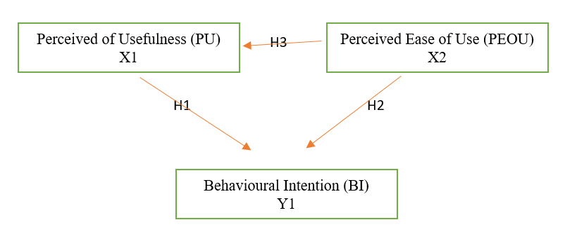

- Method
Research Design
The research design of this study is a quantitative approach, cross-sectional survey-based design focused on causal-explanatory analysis. Quantitative relies on numerical data collected by questionnaires and evaluates them using statistical analysis to test hypotheses. Cross-Sectional Survey: relies on data that is gathered from respondents at a single point in time to assess their perceptions and intentions. The causal explanatory goes beyond simple description to explain cause-and-effect (causal) relationships-specifically, how independent variables (Perceived Usefulness and Perceived Ease of Use) influence the dependent variable (Behavioral Intention) using the Technology Acceptance Model.
Population and Sample
The population of this research are students of Business Digital 2B in academic year of 2025/2026 which consist of 9 students who are village officials. The population chosen because they undergo learning activities mostly in online learning activities. This condition causes the lecturer chose online interactive quiz as assessment tool for them. Sample is a purposive sampling technique that select respondents with direct experience using the platform.
Research Instrument and Measurement
The primary data for this study were collected using a structured questionnaire administered to students following their classroom interaction with Zep Quiz. All questionnaire items were adapted from established literature regarding the Technology Acceptance Model (TAM) and tailored specifically to the context of digital student assessments.
Likert scale was employed to measure responses, ranging from 1 (Strongly Disagree) to 5 (Strongly Agree). The instrument comprises three core latent constructs measured by a total of 15 indicators: 1. Perceived Usefulness (PU): Evaluated using 5 items (PU1 to PU5) measuring the extent to which students believe that utilizing Zep Quiz enhances their learning comprehension, assessment efficiency, and academic productivity; 2. Perceived Ease of Use (PEOU): Evaluated using 5 items (PEOU1 to PEOU5) assessing students' perceptions regarding the platform's interface navigability, learnability, operational flexibility, and overall freedom from technical friction; 3.Behavioral Intention (BI): Evaluated using 5 items (BI1 to BI5) capturing students' willingness and readiness to reuse Zep Quiz and recommend it for future academic assessments.
Data Collection Procedures
The questionnaire is distributed digitally to respondents by google form after their interaction with Zep Quiz.

Table 1. The Questionnaire of Instrument
Variable | Indicators | Code
Perceived Usefulness  X1 | Using Zep Quiz as an assessment helps me understand the subject matter better. | PU 1
Perceived Usefulness  X1 | Zep Quiz makes the evaluation or quiz process in class more interesting and less boring. | PU 2
Perceived Usefulness  X1 | Using Zep Quiz improves my productivity and efficiency in completing assessment tasks. | PU 3
Perceived Usefulness  X1 | The features in Zep Quiz greatly support my needs in the learning and evaluation process. | PU 4
Perceived Usefulness  X1 | Overall, I feel Zep Quiz is a very useful assessment tool for my academic activities. | PU 5
Perceived Ease of Use  X2 | I find it easy to learn and operate Zep Quiz since the first time I used it. | PEOU 1
Perceived Ease of Use  X2 | The navigation, menus, and interface on Zep Quiz are very clear and easy to understand. | PEOU 2
Perceived Ease of Use  X2 | I rarely experience technical issues or confusion when doing quizzes via Zep Quiz. | PEOU 3
Perceived Ease of Use  X2 | Interacting and entering answers in Zep Quiz feels flexible and does not require much physical/mental effort. | PEOU 4
Perceived Ease of Use  X2 | Overall, I feel Zep Quiz is a very user-friendly assessment platform. | PEOU 5
Behavioral Intention  Y | I intend to use Zep Quiz again if the teacher uses it for assessments in the future. | BI 1
Behavioral Intention  Y | I would recommend classmates to use Zep Quiz in learning activities or quizzes. | BI 2
Behavioral Intention  Y | I am motivated to explore further the features available in Zep Quiz. | BI 3
Behavioral Intention  Y | If given a choice, I would prefer assessments using Zep Quiz compared to conventional methods (such as paper or other less interactive platforms). | BI 4
Behavioral Intention  Y | I plan to remain active in using Zep Quiz if it is applied routinely in class. | BI 5

Data Analysis Techniques
1. Instrument Quality Testing (Prerequisite Tests)
Before testing the hypotheses, the quality of the research instrument was evaluated to ensure validity and reliability:
Validity Test was evaluated using Pearson’s Product-Moment Correlation. An item is considered valid if the calculated significance value (Sig. 2-tailed) is less than 0.05 (p < 0.05) when correlated with the total score of its respective construct.
Reliability Test was measured using Cronbach’s Alpha coefficient. A construct is deemed reliable and consistent if its Cronbach’s Alpha value exceeds the threshold of 0.60 (> 0.60).
2. Classical Assumption Test
Prior to running the multiple linear regression analysis for Hypotheses 1 and 2, classical assumption tests were performed:
Normality Test: Assessed using the Kolmogorov-Smirnov test to verify whether the residual data were normally distributed (p > 0.05).
Multicollinearity Test: Evaluated through the Tolerance value (> 0.10) and Variance Inflation Factor (VIF) (< 10) to ensure the absence of high inter-correlations among the independent variables.
Linearity Test: Checked to confirm a linear relationship between the independent variables and the dependent variable.
3. Hypotheses Testing
To evaluate the three proposed hypotheses, the following SPSS analytical tools were implemented:
Multiple Linear Regression Analysis (H1 and H2): Conducted to examine the simultaneous and partial effects of Perceived Usefulness (X1) and Perceived Ease of Use (X2) on Behavioral Intention (Y). The evaluation relies on the t-statistic and the significance value (p-value). A hypothesis is accepted if the significance value is less than 0.05 (p < 0.05). Additionally, the coefficient of determination (R²) was analyzed to determine the percentage of variance in Behavioral Intention explained by the independent variables.
Simple Linear Regression Analysis (H3): Conducted to test the direct effect of Perceived Ease of Use (X2) on Perceived Usefulness (X1). Similar to the multiple regression, significance is established if the p-value is less than 0.05 (p < 0.05).

- Result and Discussion
Instrument Quality Testing (Prerequisite Tests)
This test was use to check the validity and reliability of the elements of each question in questionnaire. Construct validity was assessed using Pearson correlation analysis. With a sample size of N = 9 at the 5% significance level, the critical threshold was set at r = 0.666. Items yielding a calculated coefficient below this threshold were deemed invalid, whereas those exceeding 0.666 were accepted as valid. The correlation outcomes generated via SPSS are detailed on table 2:

Table 2. Validity Test
Code | RCorrelation | Rvalue Sig 5%  (N=9) | Result
PU 1 | 0.948 | 0.666 | Valid
PU 2 | 0.796 | 0.666 | Valid
PU 3 | 0.978 | 0.666 | Valid
PU 4 | 0.978 | 0.666 | Valid
PU 5 | 0.978 | 0.666 | Valid
PEOU 1 | 0.839 | 0.666 | Valid
PEOU 2 | 0.948 | 0.666 | Valid
PEOU 3 | 0.923 | 0.666 | Valid
PEOU 4 | 0.901 | 0.666 | Valid
PEOU 5 | 0.808 | 0.666 | Valid
BI 1 | 0.880 | 0.666 | Valid
BI 2 | 0.989 | 0.666 | Valid
BI 3 | 0.989 | 0.666 | Valid
BI 4 | 0.989 | 0.666 | Valid
BI 5 | 0.989 | 0.666 | Valid

As presented in Table 2, all 15 questionnaire items across the three constructs: Perceived Usefulness (PU 1–5), Perceived Ease of Use (PEOU 1–5), and Behavioral Intention (BI 1–5) yielded calculated Pearson correlation coefficients (r) exceeding the critical threshold of 0.666 at the 5% significance level (N = 9). The correlation values ranged from 0.796 to 0.989. Consequently, all items demonstrated acceptable construct validity.
Reliability testing was conducted using the Cronbach’s alpha coefficient. This test was conducted as a one-time measurement using SPSS software. If the reliability test yields a Cronbach’s Alpha coefficient (α) > 0.70. As (Palapa & Saifudin, 2021) notes, valid items ensure that the indicators form a reliable, credible measure of the variable. Because all items passed the validity test, the instrument is proven trustworthy for further analysis. Conversely, if the Cronbach’s alpha coefficient (α) is < 0.70, the questionnaire items used to measure a variable are considered unreliable. A good variable must be both valid and reliable.

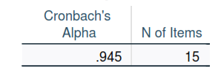
Picture 1. All Variable Reliability Scale

Picture 1 showed that all items of variable in questionnaire are reliable, the Cronbach’s alpha coefficient (α) reaches 0.945 or more than 0.70 thus it categorized as reliable.

Classical Assumption Test
- Normality Test
The normality of the data can be assessed using a histogram and a normal P-P plot generated with SPSS. If the histogram shows a distribution pattern that does not deviate significantly, the data is considered to be normally distributed; and if the points on the normal P-P plot approach the diagonal line, it can be concluded that the data is normally distributed (Palapa 2021).
Picture 2. P-P Plot Regression
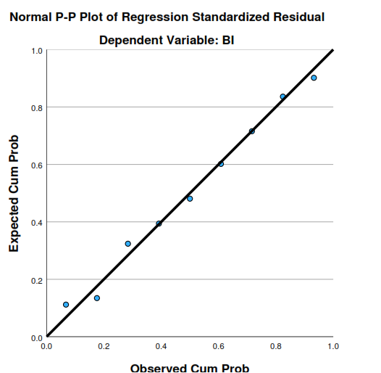

The P-P plot shows that the points form a pattern close to the diagonal line, which means the data is normally distributed.
The researcher also used Kolmogorov-Smirnov test to verify whether the residual data were normally distributed (p > 0.05) that can be seen on Picture 3.

Picture 3. Kolmogorov-Smirnov Test
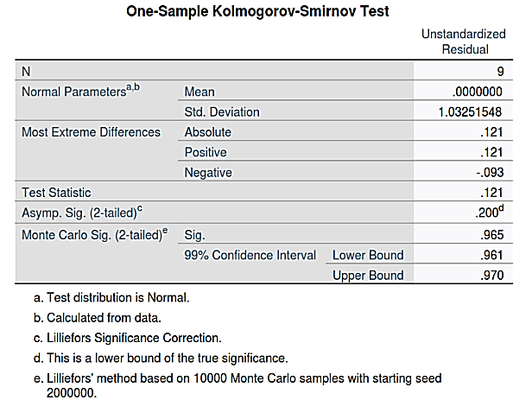

The SPSS output indicates an Asymp. Sig. (2-tailed) value of 0.200, which exceeds the 0.05 significance threshold. Therefore, the data is normally distributed

b. Multicollinearity Test
Multicollinearity occurs when two or more independent variables in a multiple linear regression model are highly correlated with one another. According to Nufal (2025), this overlap in shared variance makes it difficult to isolate and determine the distinct, individual effect of each predictor on the dependent variable. It can be evaluated through the Tolerance value (> 0.10) and Variance Inflation Factor (VIF) (< 10) to ensure the absence of high inter-correlations among the independent variables.
Picture 4. Coefficients of Multicollinearity
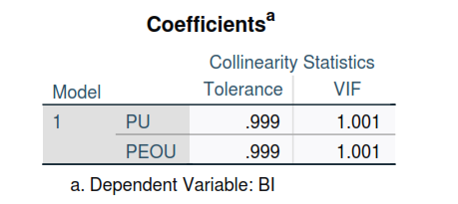

Picture 4 shows that the Tolerance values for PU (0.99) and PEOU (0.99) are all greater than 0.10, and the VIF values of PU (1.01) and PEOU (1.01) those are all below 10. Therefore, it can be concluded that no multicollinearity exists among the independent variables, confirming that the regression model is statistically stable and reliable for hypothesis testing.
c. Linearity Test
Linearity is a fundamental assumption in regression analysis, which assumes a linear relationship between the independent and dependent variables (Naufal et al., 2025). The criterions of linearity are Sig. Deviation from Linearity > 0.05 and F value < F table. The linearity of Perceived of Use and Behavioral Intention is presented on Picture 5.

Picure 5. Linearity of Perceived of Usefulness and Behavioural Intention
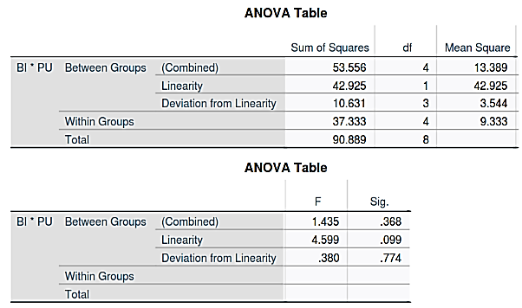

Based on the linearity test results, the relationship between the variables is confirmed to be linear. This is supported by two main findings: first, the significance value of 0.774 is greater than the 0.05 threshold (0.774 > 0.05); and second, the calculated F-value of 0.380 is lower than the critical F-table value of 6.59 (determined using 3 and 4 degrees of freedom at a 5% significance level), indicating that there is no significant deviation from linearity.
Further, the linearity of Perceived of Ease of and Behavioral Intention is presented on Picture 6.

Picture 6. Linearity of Perceived of Ease of Use ana Behavioural Intention
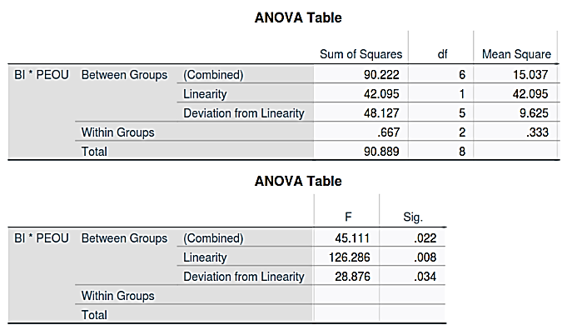

The results confirm that the relationship between the variables is not linear. This conclusion is supported by two main findings from the test for linearity: first, the significance value of 0.034 is less than the standard threshold of 0.05 (p < 0.05); and second, the calculated F-value of 28.876 exceeds the critical F-table value of 19.33 (28.876> 19.33, determined using 5 and 2 degrees of freedom at a 5% significance level). Together, these metrics indicate a statistically significant deviation from linearity.
Because real-world data often contain curvilinear or complex interactions, linear models can yield misleading results. Consequently, techniques like scatterplots, residual plots, and curve estimation are utilized to assess data linearity (Martaningtyas et al., 2024).
Based on the result and the data above, the researcher changed to measure linearity into curve estimation.
The regression analysis evaluating the effect of Perceived Ease of Use (PEOU) on the dependent variable indicates a statistically significant relationship (F = 6.039, p = 0.044). The correlation coefficient (R) of 0.681 demonstrates a strong positive linear association between PEOU and the dependent variable. Furthermore, the coefficient of determination (R²) is 0.463, meaning that PEOU explains 46.3% of the variance in the dependent variable, while the remaining variance is attributed to other factors outside this model.
Picture 7. Curve Estimation of Perceive of Usefulness and Behavioral Intention
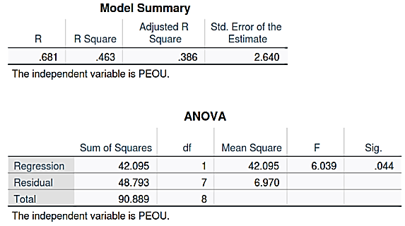

The last, the linearity of Perceived of Ease of and Perceived of Use is shown on Picture 8.

Picture 8. The linearity of Perceived of Ease of and Perceived of Use

The assumption of linearity fails. The Deviation from Linearity is statistically significant (p < 0.05), proving that the relationship between PU and PEOU is non-linear (curved) rather than a simple straight line. Consequently, a standard linear regression model is insufficient, necessitating the application of a non-linear or alternative curve estimation model to accurately capture the pattern of the data. The researcher measured the non-linearity by use curve fit, the component that the researcher used were linear, logarithmic, quadratic, and exponential. The data displayed on table 3.
Table 3. Non-Linear Measure
Criterions | R Square | F | Sig.
Linear | 0.01 | 0.07 | 0.934
Algorithmic | 0.00 | 0.00 | 0.995
Quadratic | 0.106 | 0.35 | 0.714
Exponential | 0.03 | 0.22 | 0.885

Based on the table 3 the researcher concluded that:
Significance Levels (Sig.): All models yield significance values far above the standard threshold of 0.05 (p > 0.05). The values are 0.934 for Linear, 0.995 for Algorithmic, 0.714 for Quadratic, and 0.885 for Exponential. This indicates that none of the models achieve statistical significance.
Coefficient of Determination (R²): The explanatory power across all models is exceptionally weak. Although the Quadratic model shows a marginally higher R² of 0.106 (indicating it explains 10.6% of the variance) compared to Linear (0.01), Algorithmic (0.00), and Exponential (0.03), its F-statistic (0.35) and significance level (0.714) confirm that the fit is still statistically unreliable.

3. Hypotheses Testing
To address the research objectives and test the proposed hypotheses, statistical evaluations were performed to determine the significance and magnitude of the effects.

- Perceived Usefulness exerts a positive and significant effect on students' Behavioral Intention to use Zep Quiz as a digital assessment tool

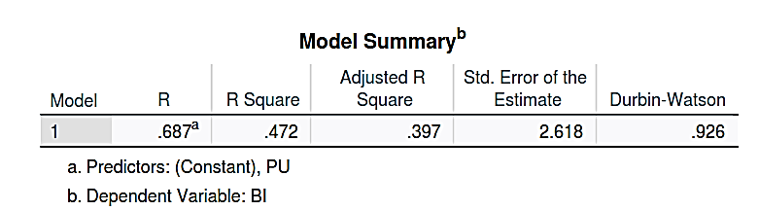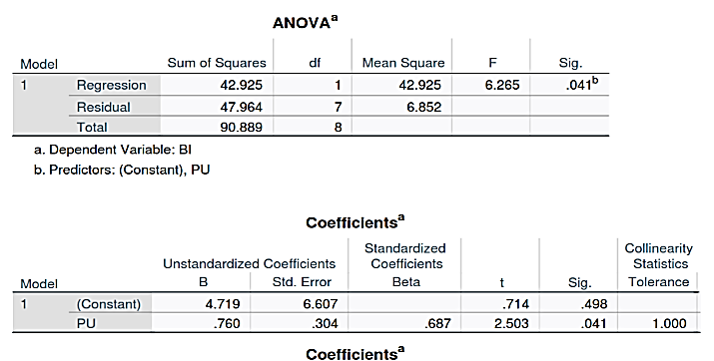Picture 9. The Result of Hypothesis Testing PU on BI

The R Square value of 0.472 indicates that 47.2% of the variance in Behavioral Intention (BI) is explained by Perceived Usefulness (PU). The remaining 52.8% is influenced by other variables outside this model.
The t-statistic for the predictor PU is 2.503, which exceeds the standard critical threshold of 2.365 (t-table for df 7) for a two-tailed test at a 5% significance level, showing a strong t-value magnitude.
The significance value for PU is 0.041, which is less than the threshold of 0.05 (0.041 < 0.05). This confirms that the effect of PU on BI is statistically significant. It can be concluded that the hypothesis proposing that Perceived Usefulness significantly influences Behavioral Intention is accepted.

- Perceived Ease of Use exerts a positive and significant effect on students' Behavioral Intention to use Zep Quiz as a digital assessment tool
Picture 10. The Result of Hypothesis Testing PEOU on BI
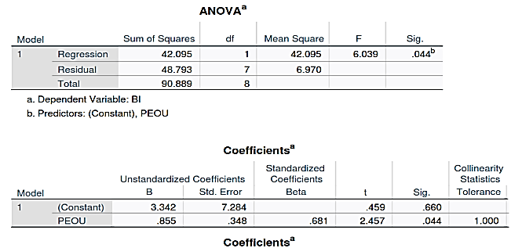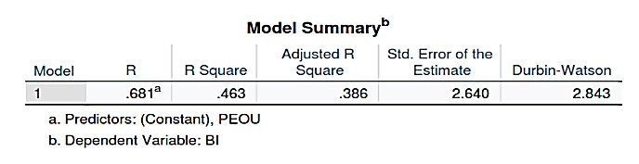

The linear regression analysis examining the effect of Perceived Ease of Use (PEOU) on Behavioral Intention (BI) demonstrates a statistically significant positive relationship with t = 2.457, p = 0.044 and df = 7. The model yields an R Square of 0.463, indicating that PEOU accounts for 46.3% of the variance in BI. Since the calculated t-statistic exceeds the critical threshold for df = 7 at the 5% significance level (2.457 > 2.365). Meanwhile, the Sig. value of PEOU is 0,044 which is less than 0.05. The conclusion of the result is the hypothesis proposing that Perceived Ease of Use significantly influences Behavioral Intention is accepted.

- Perceived Ease of Use exerts a positive and significant effect on students' Perceived Usefulness to use Zep Quiz as a digital assessment tool
Picture 11. The Result of Hypothesis Testing PEOU on PU
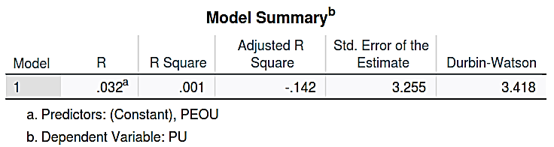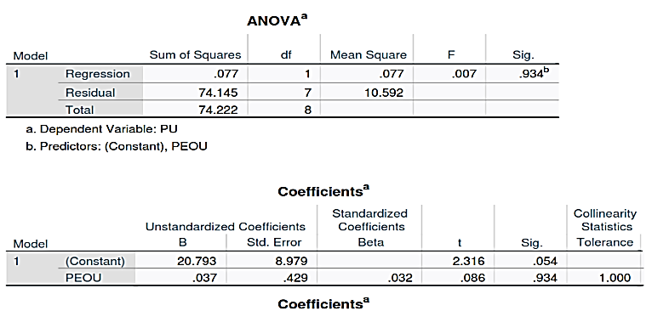

The result of R Square of 0.001 indicating that PEOU fails to account for any meaningful variance in PU. The t-statistic for the predictor PEOU is 0.086 is less than 2.365 (df 7 two tailed test at 5%). Then, the significant value for PEOU is 0.934 that bigger than threshold 0.05 (0.934 > 0.05). the hypothesis proposing that Perceived Ease of Use significantly influences Perceived Usefulness is rejected.

Discussion
Hypothesis 1 is accepted. Perceived Usefulness significantly drives students' willingness to adopt Zep Quiz (t = 2.503, p = 0.041), accounting for 47.2% of the variance (R² = 0.472). The acceptance of Hypothesis 1 indicates that students perceive the Zep Quiz application as highly useful because it significantly enhances their academic efficiency. Key features such as immediate feedback on errors, competitive elements like leader boards and point tracking, and real-time score reporting allow students to engage in self-evaluation without the delay of traditional grading. This efficiency is particularly vital for these students, who are village administration officials balancing rigorous coursework with demanding professional responsibilities. According to Amin cited in (Narayan et al., 2025) particular system will improve their performance, thereby positively influencing their intention to use it. Furthermore, the findings of this study reinforce previous research by (Bagus et al., 2022; Suki & Suki, 2011; Sumardi & Andreani, 2021), which demonstrates that perceived usefulness has a positive effect on behavioral intention to use.
Hypothesis 2 is supported (R² = 0.463, t = 2.457, p = 0.044). The results indicate that Perceived Ease of Use exerts a strong, direct, and positive effect on Behavioral Intention, explaining 46.3% of the variance. Despite Zep Quiz’s immersive, game-like architecture which includes custom avatars, adventure themes, and real-time multiplayer layouts its intuitive navigation successfully minimizes cognitive load for users. Zep Quiz also offers clear advantages through its visual appeal and simple navigation, enabling students to use it effortlessly without complex guides. Accessible across multiple devices (smartphones, tablets, and laptops) for both in-class and independent home use, the platform ensures low effort in technology adoption. According to (Narayan et al., 2025), perceived ease of use refers to the degree to which an individual believes that using a specific system or technology will be free of effort. In the context of information and communication technology, perceived ease of use plays a vital role in influencing users' intention to adopt that technology.
This study aligns with (T. K. Ramadhan & Saputro, 2024), who found that Perceived Ease of Use has a significant impact on Behavioral Intention. When users find a system easy to use, their willingness to adopt it increases. Furthermore, when users feel comfortable and encounter no difficulties, their loyalty to the system tends to grow, leading them to utilize the offered technology more frequently (Narayan et al., 2025).
Hypothesis 3 that about Perceived Ease of Use significantly influences Perceived Usefulness is rejected. The statistical results reveal an R² value of 0.001, indicating that Perceived Ease of Use fails to account for any meaningful variance in Perceived Usefulness. This reflects prior research by (Pratista & Marsasi, 2024), which suggests that perceived ease of use may have a minimal or negative impact. This outcome can likely be attributed to the profile of the participants, a significant proportion of whom are regular technology users with strong competencies in information technology. The statistical independence observed between PEOU and PU aligns with the theoretical distinction proposed by (Sagnier et al., 2020), who noted that users look to goal achievement when assessing ease of use, but look to need fulfilment when evaluating usefulness. In the context of Zep Quiz, students may easily grasp the operational mechanics for achieving immediate interaction goals, but this interface simplicity operates separately from whether they believe the gamified platform fulfils their complex learning objectives or need fulfilment. In this research the respondents are tech-competent adult learners or village administrative officials, handling a simple application interface (ease of use) is second nature to them. They don't equate "easy navigation" with "it makes me more productive." An application can be very easy to use, but that doesn't automatically mean it solves their heavy academic workload or fulfils their deeper study needs. They keep goals (usability) and needs (usefulness) separate.

- Conclusion
In response to the limited empirical research on how students' perceptions drive the adoption of gamified platforms, this study applied the Technology Acceptance Model (TAM) to evaluate Zep Quiz as a formal digital assessment tool among digital business students. The findings offer a clear picture of what actually motivates learners to embrace or question these tools.
This study applied the Technology Acceptance Model (TAM) to evaluate Zep Quiz as a digital assessment tool among adult vocational learners, such as village administration officials, who balance heavy workloads with academic studies.
First, the results confirm that Perceived Usefulness plays a vital direct role in shaping students' willingness to adopt the platform (H1). Students embrace Zep Quiz because it genuinely boosts their academic efficiency through features like instant feedback, score tracking, and gamified elements that eliminate the delays of traditional grading.
Second, Perceived Ease of Use also strongly drives behavioral intention (H2). The platform's multi-device accessibility and intuitive, game-like interface successfully minimize effort and cognitive load, making it seamless for students to use across various devices without complex guides.
However, the study also uncovered an interesting deviation from classical TAM: Perceived Ease of Use did not significantly drive Perceived Usefulness (H3). In practice, this means students evaluate a platform's instructional value (usefulness) separately from its navigation simplicity (ease of use)—recognizing that an interactive interface does not automatically guarantee deep academic benefit.

References

Andry, J. F., Herlina, H., & Susanto, F. M. (2023). Analisis Deskriptif Perilaku Konsumen Shopee : Technology Acceptance Model ( TAM ). Journal of Technology and Informatics (JoTI), 4(2), 63–68. https://doi.org/10.37802/joti.v4i2.318
Bagus, I., Udayana, N., Cahya, A. D., & Aqdella, F. A. (2022). The Effect of Perceived Usefulness, Perceived Ease of Use on Behavioral Intention to Use Through the Intervening Attitude Toward Using Variables in The Study of Shopeepay E-Wallet Services (Case study on ShopeePay Users in Yogyakarta). Journal of Applied Management and Business Journal of Applied Management and Business, 8(1), 29–40. https://doi.org/http://dx.doi.org/10.26737/jtmb.v8i1.3144
Izmala, A., Yusuf, D., Meilisa, M., & Iskandar, S. (2025). Peran Guru Dalam Mendorong Inovasi Pembelajaran di Era Digital. Pendas : Jurnal Ilmiah Pendidikan Dasar, 10(2), 292–302. https://doi.org/https://doi.org/10.23969/jp.v10i2.25743
Karika, N. L. P., & Budiarta, L. G. R. (2025). Quizizz in EFL Classroom Learning : Students ’ Perception and Challenges. The Art of Teaching English as a Foreign Language (TATEFL), 6(1), 28–40. https://doi.org/https://doi.org/10.36663/tatefl.v6i1.939 Quizizz
Lee, Y., Kozar, K. A., & Larsen, K. R. T. (2003). The Technology Acceptance Model : Past , Present , and Future. Communications of the Association for Information Systems Volume, 12(1), 751–780. https://doi.org/DOI:10.17705/1CAIS.01250
Martaningtyas, N. U., Septiyaningrum, E. A., & Maulana, Z. (2024). Dampak Pelanggaran Asumsi Klasik Terhadap Kesalahan Inferensi Dalam Analisis Ekonometrika. SYNERGY Jurnal Ilmiah Multidisiplin, 1(4), 255–265. https://e-journal.naureendigition.com/index.php/sjim/article/view/1067
Martí-parreño, J., Seguí-mas, D., & Seguí-mas, E. (2016). Teachers ’ Attitude towards and Actual Use of Gamification. Procedia - Social and Behavioral Sciences, 228(June), 682–688. https://doi.org/10.1016/j.sbspro.2016.07.104
Musrifa, R., & Ayu, I. P. (2026). 7 th Grade Students ’ Perceptions of Zep Quiz for Gamified Vocabulary Learning. Journal of English Language and Education, 11(4), 371–378. https://doi.org/https://doi.org/10.31004/jele.v11i4.2700
Narayan, A., Rachman, F. N., & Rivaldo, A. (2025). Pengaruh Perceived Ease of Use , Perceived Usefulness terhadap Behavioral Intention melalui Attitude Towards dalam Penggunaan Aplikasi Gopay diIndonesia. Jurnal Bisnis Dan Manajemen West Science, 4(04), 573–600. https://doi.org/https://doi.org/10.58812/jbmws.v4i04.2965
Naufal, M. J., Ompusunggu, D. P., Sinaga, R. A., Sitohang, M. A., & Gunawan, T. N. (2025). A Theoretical Study of Multicollinearity and Linearity in Econometric Models for Economic Research. Balance Jurnal Ekonomi, 21(1), 43–52. https://doi.org/DOI:10.26618/jeb.v21i1.17031
Nisdayanti, N., Ahmad, A., & Usman, A. (2025). The Effect of Using the ZEP Quiz Application on Fifth- Grade Students ’ Learning Outcomes in Pancasila Education. Journal of Education and Learning Science, 05(02), 169–184. https://doi.org/https://doi.org/10.56404/jels.v5i2.420
Nursanti, Y. B., Sujadi, I., Kurniawati, I., Andriatna, R., & Wulandari, A. N. (2025). The emergent role of artificial intelligence in Mathematics education : Examining students ’ acceptance and perception. Journal of Educational Management and Instruction, 5(2), 249–264. https://doi.org/https://orcid.org/0009-0006-7403-132X Faculty
Palapa, A., & Saifudin, I. (2021). Analisa Pengaruh Technology Acceptance Model (TAM) Pada Aplikasi Pendaftaran Penilaian Training Record Book (Smile 05) Studi Pada PUKP 05 Semarang. Majalah Ilmiah Bahari Jogja, 19(1), 70–86. https://doi.org/10.33489/mibj.v19i1.259
Pratista, N. D., & Marsasi, E. G. (2024). Effects Of Perceived Usefulness And Perceived Ease Of Use For Driving Purchase Intention. Jurnal Ekonomi E-JE, 28(03), 488–509. https://doi.org/http://dx.doi.org/10.24912/e.v28i3.1940
Putra, R. W. P., Karimullah, I. W., & Mustofa, M. (2025). Zep Quiz in Action : Empowering Students ’ Vocabulary through Gamified Learning. IDEAS Is Licensed Journal on Language Teaching and Learning, Linguistics and Literature, 13(2), 5461–5473. https://doi.org/10.24256/ideas. v13i2.8057
Rafique, H., Almagrabi, A. O., Shamim, A., Anwar, F., & Bashir, A. K. (2020). Investigating the acceptance of mobile library applications with an extended technology acceptance model (TAM). Computers & Education, 145. https://doi.org/10.1016/j.compedu.2019.103732
Ramadhan, R. S., Wirdani, R. R., Delpina, H., & Nelwati, S. (2025). Pendidikan di Era Teknologi Informasi dan Komunikasi. JURNAL MEDIA AKADEMIK (JMA), 3(1), 1–12. https://doi.org/DOI: 10.62281
Ramadhan, T. K., & Saputro, E. P. (2024). Al-Kharaj : Jurnal Ekonomi , Keuangan & Bisnis Syariah Al-Kharaj : Jurnal Ekonomi , Keuangan & Bisnis Syariah. Al-Kharaj: Jurnal Ekonomi, Keuangan & Bisnis Syariah, 6(6), 5501–5517. https://doi.org/10.47467/alkharaj.v6i6.2856
Ramadhani, H., & Monalisa, S. (2017). Analisis Penerapan Sistem Informasi Pengelolaan Nilai Raport Menggunakan Metode TAM. Jurnal Ilmiah Rekayasa Dan Manajemen Sistem Informasi, 3(2), 65–69. https://doi.org/https://doi.org/10.24014/rmsi.v3i2.4303
Ratnawati, D., & Wahyuni, S. (2026). The Effect of “Zep Quiz” in Assessing Students’ Reading Comprehension Skill. Journal of Educational Sciences Journal, 10(1), 468–479. https://doi.org/https://doi.org/10.31258/jes.10.1.p.468-479 This
Sagnier, C., Loup-escande, E., Lourdeaux, D., Thouvenin, I., Sagnier, C., Loup-escande, E., Lourdeaux, D., Thouvenin, I., & Vallery, G. (2020). User Acceptance of Virtual Reality : An Extended Technology Acceptance Model. International Journal of Human-Computer Interaction, 36(2), 1–15. https://doi.org/10.1080/10447318.2019.1708612
Septrianto, Y., Suhartono, S., & Munir, A. (2026). Responses of Eleventh Grade Students to the Gamified ZEP QUIZ in Teaching Reading Comprehension : A Quantitative Inquiry. Journaal of General Education and Humanities, 5(3), 3561–3569. https://doi.org/https://doi.org/10.58421/gehu.v5i3.1559
Suki, N. M., & Suki, N. M. (2011). Exploring the Relationship Between Perceived Usefulness, Perceived Ease of Use, Perceived Enjoyment, Attitude and Subscribers’ Intention Towards Using 3G Mobile Services. Journal of Information Technology Management, XXII(1), 1–7. https://jitm.ubalt.edu/XXII-1/article1.pdf
Sumardi, D. H., & Andreani, F. (2021). Pengaruh Perceived Usefulness dan Perceived Ease of Use Terhadap Usage Behavior Melalui Intention to Use Pada Konsumen Online Shop Sayurbox di Surabaya. Agora, 9(1), 1–6.
Sylvia, P. H., Asmara, C. H., & Muhammad, R. N. (2026). Investigating The Impact of ZEP Quiz Gamified Assessment on Students ’ Reading Comprehension and Perceptions. Journal of English Language and Education, 11(4), 80–86. https://doi.org/https://doi.org/10.31004/jele.v11i4.2501
Triyana, T., & Sutarna, N. (2026). Jurnal Pedagogik Pendidikan Dasar Development of Formative Assesment Instrument Based on Zep Quiz On Students ’ Learning Motivation in Subjects IPAS Grade IV of Ciwaru. Jurnal Pedagogik Pendidikan Dasar, 13(1), 189–198. https://doi.org/https://doi.org/10.17509/jppd.v13i1.101296
Wang, A. I., & Tahir, R. (2020). The effect of using Kahoot ! for learning – A literature review. Computers & Education, 149(May 2019), 103818. https://doi.org/https://doi.org/10.1016/j.compedu.2020.103818
Wulandari, D. A., Nainggolan, E. E., & Satria, B. (2026). Students Perception of Using Zep Quiz in English Language Learning at The Tenth Grade of SMAN1 Tanjungpinang. JOURNAL OF LANGUAGE EDUCATION DEVELOPMENT, 8(2).
Zahra, N. M. N. N., Barnas, B., & Badaruddin, S. (2026). Effect of gamified Zep Quiz on dance motivation: A quasi-experimental study Najwa. Curricula: Journal of Curriculum Development, 5(2), 879–896. https://doi.org/https://doi.org/10.17509/curricula.v5i2.674

